**Route 66: Historic Structures in McLean County**

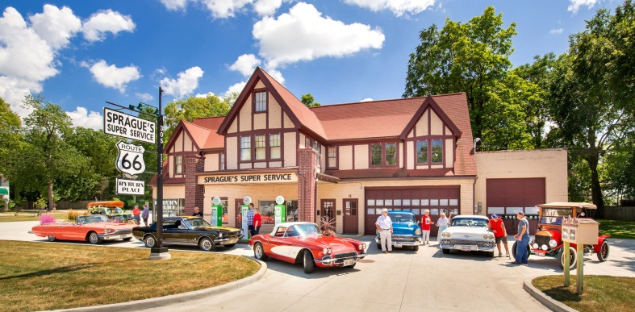**Structure**Sprague’s Super Service

**Parcel**1427102008

**Address**305 E. Pine Street

**City**Normal

**Year(s)**1931

**Building Status** (Restored/Original/Demolished)  
Restored

**Notes**Local landmark designation, August 15, 2011  
National Register designation, April 25, 2008

--------------------------------------------------------------------------------------------------------------------------------------------------------

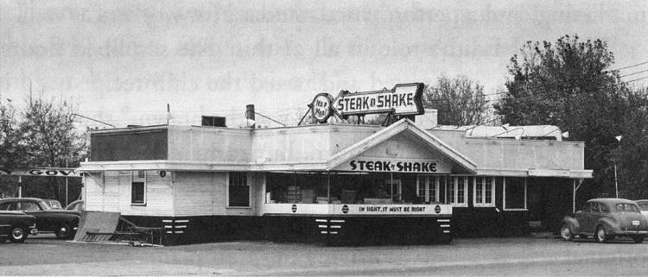**Structure**Steak ‘n Shake

**Parcel**1433128017

**Address**1219 S Main Street

**City**Normal

**Year(s)**1934

**Building Status** (Restored/Original/Demolished)  
Original

**Notes**The first Steak ‘n Shake was opened by Gus Belt after he added a food menu to a Shell service station. Original building still stands, housing Monical’s Pizza since the 1990s.

--------------------------------------------------------------------------------------------------------------------------------------------------------

**Structure**  
Gene's Dairy Delight

**Parcel**  
2109145019

**Address**  
1019 S. Main Street

**City**  
Bloomington

**Year(s)**

**Building Status** (Restored/Original/Demolished)  
Original

**Notes**

--------------------------------------------------------------------------------------------------------------------------------------------------------

**Structure**  
Lucca Grill

**Parcel**

**Address**

**City**

**Year(s)**

**Building Status** (Restored/Original/Demolished)

**Notes**

--------------------------------------------------------------------------------------------------------------------------------------------------------